Week 7 - Day 2

Table of Contents

[CH101-008 UA Fall 2016](/CH101-008/)

[About](/CH101-008/about/)

# Week 7 - Day 2

Sep 28, 2016

Download Word (docx):

## Navigate using audio

[Quizlet](https://quizlet.com/_2l4077)

# Announcements

* No recitation tonight

# Ch 6 - Lecture 1 (Chemical Bonding I)

## Covalent Bonding Model vs. Reality

* Audio 0:01:17.116824
* molecular compounds have low melting points and boiling points
  + MP generally < 300°C
  + molecular compounds are found in all 3 states at room temperature
* melting and boiling involve breaking the attractions between the molecules, but not the bonds between the atoms
  + the covalent bonds are strong
  + the attractions between the molecules are generally weak
  + the polarity of the covalent bonds influences the strength of the intermolecular attractions

## Intermolecular Attractions vs. Bonding

* 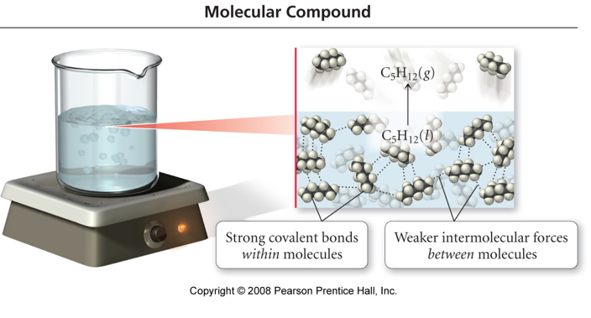

## Covalent Bonding Model vs. Reality

* Audio 0:03:16.295803
* some molecular solids are brittle and hard, but many are soft and waxy
* the kind and strength of the intermolecular attractions varies based on many factors
* the covalent bonds are not broken molecular compounds do not conduct electricity in the liquid state
* molecular acids conduct electricity when dissolved in water, but not in the solid state
* in molecular solids, there are no charged particles around to allow the material to conduct
* when dissolved in water, molecular acids are ionized, and have the ability to move through the structure and therefore conduct electricity
* Audio 0:04:17.779258
* 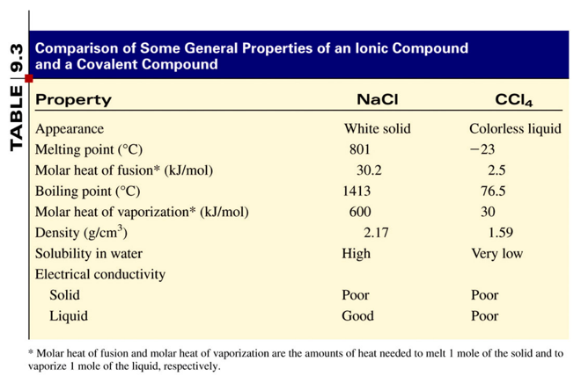

## Polar Covalent Bonding

* Audio 0:05:06.884522
* Covalent bonding between unlike atoms results in unequal sharing of the electrons.
  + One atom pulls the electrons in the bond closer to its side.
  + One end of the bond has larger electron density than the other.
* The result is a polar covalent bond.
  + Bond polarity
  + The end with the larger electron density gets a partial negative charge.
  + The end that is electron deficient gets a partial positive charge.

## Electronegativity (EN)

* Audio 0:06:39.736104
* A measure of an elements ability to pull electrons toward it
* An empirical scale drawn from measured properties of many molecules
* provides “rule of thumb” to predict molecular properties

## Electronegativity

* Audio 0:07:30.692317
* The ability of an atom to attract bonding electrons to itself is called *electronegativity*.
* An empirical scale drawn from measured properties of many molecules
* provides “rule of thumb” to predict molecular properties
* The larger the difference in electronegativity, the more polar the bond.
  + Negative end toward more electronegative atom
* Audio 0:07:45.217060
* Scale defined so Fluorine is the most electronegative, Francium the least
* Increases across a period (left to right) and decreases down a group (top to bottom)
  + Noble gas atoms are not assigned EN values.
  + Opposite of atomic size trend
  + 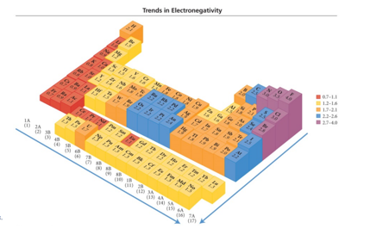
  + Audio 0:09:56.193372
  + 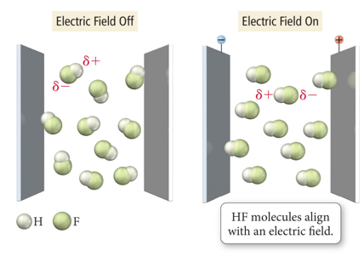

## Electronegativity Example

* Audio 0:11:11.916765
* 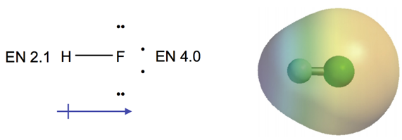

## Bond Dipole Moments

* Audio 0:11:29.357496
* Dipole moment, µ, is a measure of bond polarity.
  + A dipole is a material with a + and − end.
  + It is directly proportional to the size of the partial charges (q) and directly proportional to the distance (r) between them.
    - µ (dipole moment) = (q)(r)
  + Measured in Debyes, D
* Generally, the more electrons two atoms share and the larger the atoms are, the larger the dipole moment.
* 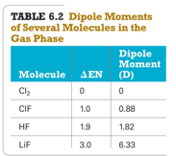

## Electronegativity Difference and Bond Type

* Audio 0:13:12.370573
* If the difference in electronegativity between bonded atoms is 0, the bond is pure covalent.
  + Equal sharing of the atoms in the bond
  + If the difference in electronegativity between bonded atoms is 0.1 to 0.4, the bond is nonpolar covalent.
* If the difference in electronegativity between bonded atoms is 0.5 to 1.9, the bond is polar covalent.
  + Unequal sharing of electrons between the atoms in the bond
* If the difference in electronegativity between bonded atoms is larger than or equal to 2.0, the bond is ionic.

## Percent Ionic Character

* Audio 0:15:43.076694
* The percent ionic character is the percentage of a bond’s measured dipole moment compared to what it would be if the electrons were completely transferred.
* The percent ionic character indicates the degree to which the electron is transferred.
* 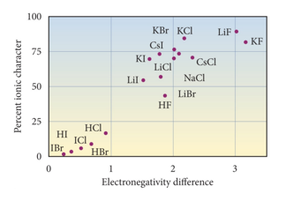

## Molecular Structure I: Octet Rule

* Audio 0:16:44.675983
* Generally eight electrons in valence shell
* exceptions for H, Li, (2 electrons) and Be and B (only 2 and 3 electrons)
* “Octet Expansion”: S, P, etc where can have more than 8 electrons when central atom

## Writing Lewis Structures for Molecular Compounds

* Audio 0:17:58.111765
* Write the correct skeletal structure for the molecule.
  + The less electronegative atom in the molecule is usually the center atom.
    - Simple molecules have a “center” atom to which all of the other atoms in the molecules are attached (bonded) to.
      * For example, for CO2, the center atom is C, so both O atoms are attached to the carbon atom.
        + Audio 0:18:55.177204
        + O–C–O
  + The more electronegative atoms are usually terminal (attached to the center atom).
    - Hydrogen atoms are always in the terminal position.
* Determine the total number of valence electrons each atom brings to form the molecule.
  + Examples:
    - For the molecule H–Br: H atom brings 1 electron and Br atoms brings 7 electrons for a total 8 electrons
    - In polyatomic ions, the charge on the ion also must be accounted. For the polyatomic ion NO2 –, a total of 18 electrons are brought in: 5 electrons from N, total 12 from O (2 oxygen atoms × 2), and 2 from the 2+ charge.

## Writing Lewis Structures for Molecular Compounds

* Audio 0:20:36.268038
* Distribute the electrons among the atoms in the molecule giving octets (or duets in the case of hydrogen) to as many atoms as possible.
  + The best practice is to place two electrons around an atom at a time.
    - Bonding pairs: electrons between two atoms
    - Nonbonding or lone pairs: electrons not participating in bonding but complete the atom’s “octet”
  + The total number of electrons brought in must be accounted for in the Lewis structure and must not violate any criteria (i.e., H atoms can only have single bonds or two electrons total).
* If any atoms lack an octet, form double or triple bonds as necessary to give them octets.
  + Atoms that can multiple bond with each other or to themselves are as follows:
    - Double bond (4 electrons or two pairs of electrons between atoms): C, O, N, S, & P
    - Triple bond (6 electrons or three pairs of electrons between atoms): C,O, N, & S

## Practice Problem Writing Lewis Structures for Polyatomic Ions

NH4+

* Audio 0:23:57.666020
* 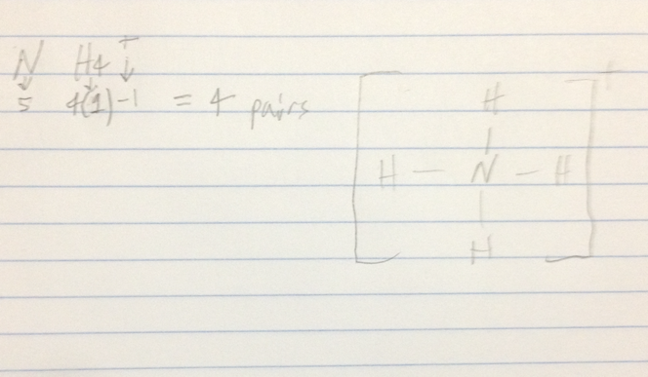

O3

* 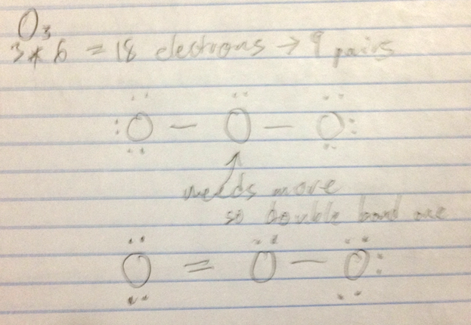

## Resonance and Formal Charges

* Audio 0:31:22.898676
* Two additional concepts to write the best possible Lewis structures for a large number of compounds
* The concepts are:
  + Resonance, used when two or more valid Lewis structures can be drawn for the same compound
  + Formal charge, an electron bookkeeping system that allows us to discriminate between alternative Lewis structures

## Resonance

* Audio 0:32:45.308690
* Lewis theory localizes the electrons between the atoms that are bonding together.
* Extensions of Lewis theory suggest that there is some degree of delocalization of the electrons; the concept is called resonance.
  + Delocalization of charge helps to stabilize the molecule.
* When there is more than one Lewis structure for a molecule that differ only in the position of the electrons, they are called resonance structures.
  + The actual molecule is a combination of the resonance forms—a resonance hybrid.
  + The molecule does not resonate between the two forms, though we often draw it that way.
    - Example: O3 molecule
* 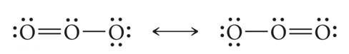
* 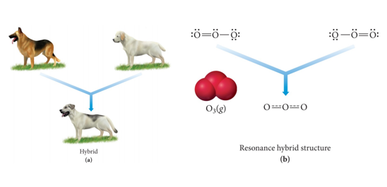
* Resonance hybrid: Just as the offspring of two different dog breeds is a hybrid that is intermediate between the two breeds (a), the structure of a resonance hybrid is intermediate between that of the contributing resonance structures (b).

## Ex

* Audio 0:38:19.039491
* 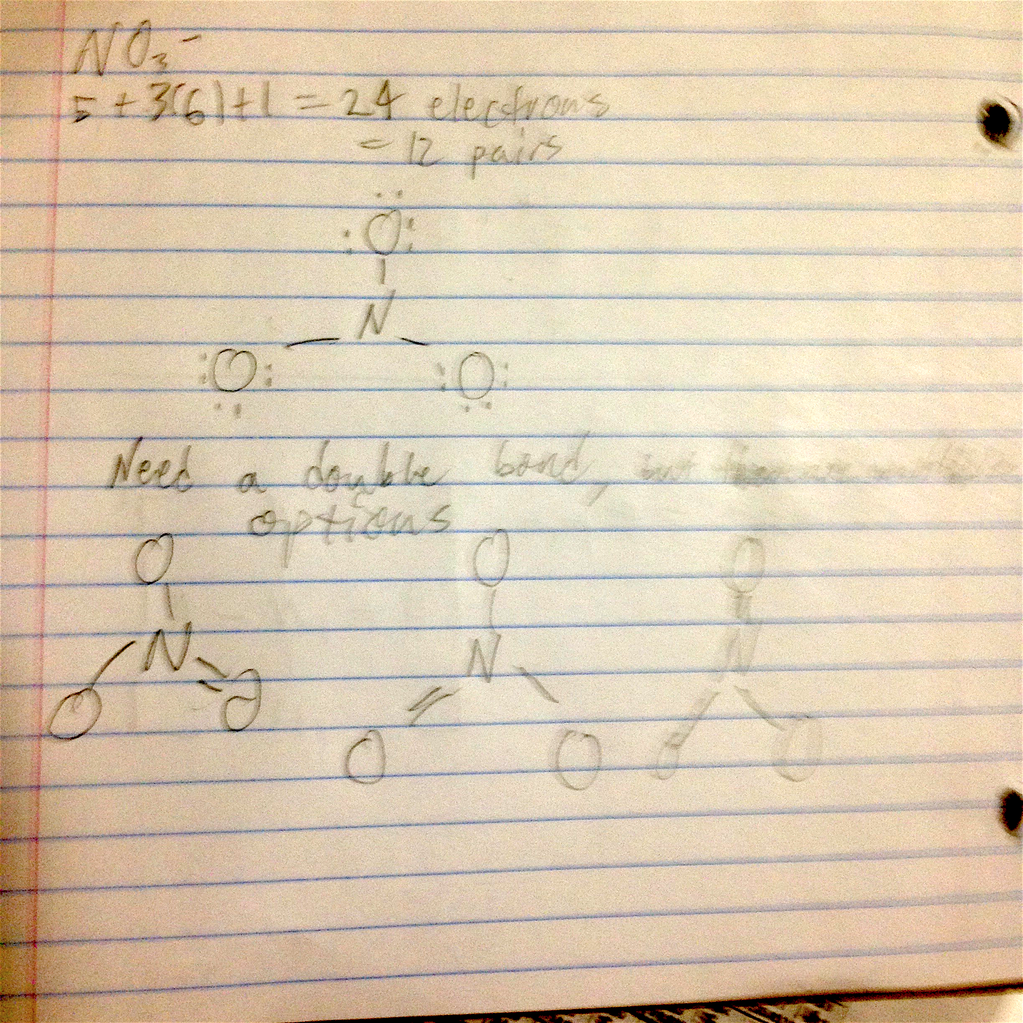

## Clicker

* Audio 0:38:59.721909
* 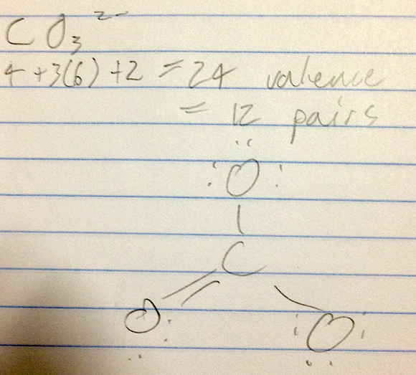
* Draw the Lewis structure for CO3^2- including any valid resonance structures.
  + two single bonds and one double bond

## Formal Charge

* Audio 0:42:50.124155
* Are all Resonance Structures equally good?
  + NO
* so how do we decide which to give more weight?
* Audio 0:43:41.519126
* charge an atom would have if all bonding electrons are shared equally between the bonded atoms. {(# of valence electrons) + (# of nonbonding electrons)- (1/2 × # of bonding electrons)}
  1. The sum of all formal charges in a neutral molecule must be zero.
  2. The sum of all formal charges in an ion must equal the charge of the ion.
  3. Small (or zero) formal charges on individual atoms are better than large ones.
  4. When formal charge cannot be avoided, negative formal charge should reside on the most electronegative atom.
* Audio 0:44:42.818811
* Example: The molecule HF has 0 (zero) formal charge.
  + The formal charge on H atom: Formal charge = 1 − [0 + ½ (2)] = 0
  + The formal charge on F atom: Formal charge = 7 − [6 + ½ (2)] = 0
  + 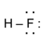

# Vocab

|  |  |
| --- | --- |
| Term | Definition |
| empirical formula | simplest whole-number ratio of the atoms of elements in a compound |
| molecular compounds have _ melting points and boiling points | low |
| polar covalent bond | results from covalent bonding between unlike atoms results in unequal sharing of the electrons |
| electronegativity | the ability of an atom to attract bonding electrons to itself |
| electronegativity _ across a period | increases left to right |
| electronegativity _ down a group | decreases |
| dipole moment (µ) | measure of bond polarity (= q * r) |
| pure covalent | the bond is this when the difference in electronegativity between bonded atoms is 0 |
| nonpolar covalent | if the difference in electronegativity between bonded atoms is 0.1 to 0.4, the bond is |
| percent ionic character | the percentage of a bond’s measured dipole moment compared to what it would be if the electrons were completely transferred |
| resonance | when two or more valid Lewis structures can be drawn for the same compound |
| formal charge | an electron bookkeeping system that allows us to discriminate between alternative Lewis structures |
| resonance structures | when there is more than one Lewis structure for a molecule that differ only in the position of the electrons |
| formal charge | charge an atom would have if all bonding electrons are shared equally between the bonded atoms |

Please enable JavaScript to view the [comments powered by Disqus.](https://disqus.com/?ref_noscript)

## CH101-008 UA Fall 2016

* CH101-008 UA Fall 2016
* [jmbeach1@crimson.ua.edu](mailto:jmbeach1@crimson.ua.edu)
* jmbeach
* hey_beach

Notes and study materials for The University of Alabama's Chemistry 101 course offered Fall 2016.